**Assignment - 2** **A Job Ready Bootcamp in C++, DSA and IOT**

Operators in C Language

**1. Write a program to print unit digit of a given number**

#include<stdio.h>

int main()

{

int num;

printf("Enter a number");

scanf("%d",&num);

printf("\nUnit digit is %d",num%10);

return 0;

}

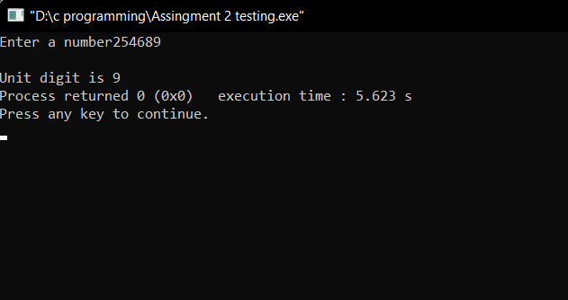

**2. Write a program to print a given number without its last digit.**

#include<stdio.h>

int main()

{

int num;

printf("Enter a number\t");

scanf("%d",&num);

printf("\n Number without last digit is %d",num/10);

return 0;

}

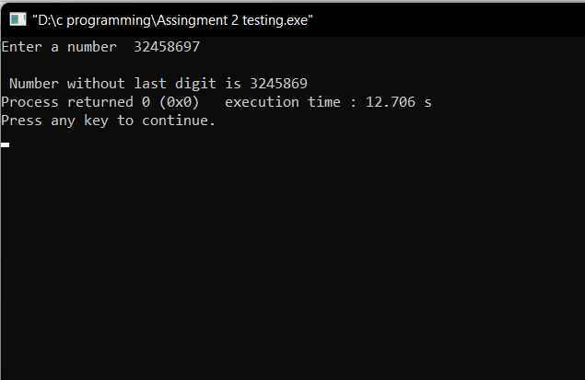

**3. Write a program to swap values of two int variables**

#include<stdio.h>

int main()

{

int a,b;

printf("Enter two numbers");

scanf("%d %d",&a,&b);

printf("a=%d b=%d",a,b);

b=a+b;

a=b-a;

b=b-a;

printf("\nNumber after swap a=%d b=%d",a,b);

return 0;

}

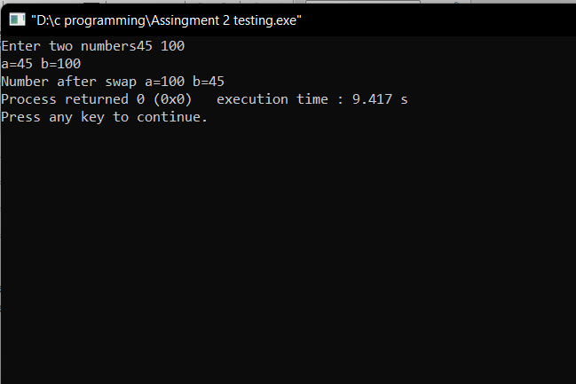

**4. Write a program to swap values of two int variables without using a third variable.**

#include<stdio.h>

int main()

{

int a,b,c;

printf("Enter two numbers");

scanf("%d %d",&a,&b);

printf("a=%d b=%d",a,b);

c=b;

b=a;

a=c;

printf("\nNumber after swap a=%d b=%d",a,b);

return 0;

}

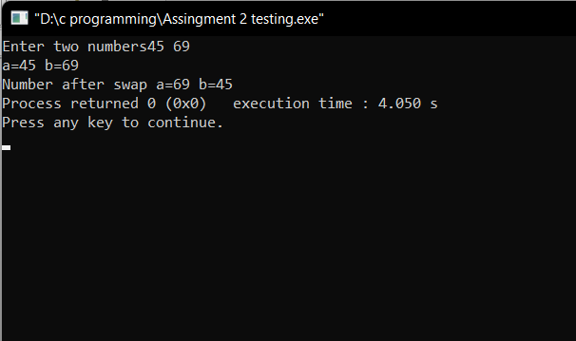

**5. Write a program to input a three-digit number and display the sum of the digits.**

#include<stdio.h>

int main()

{

int n,sum,s,t,u,x;

printf("Enter a three digit numbers");

scanf("%d",&n);

x=n/10;

s=n%10;

t=x%10;

u=x/10;

sum=(s+t+u);

printf("sum is %d",sum);

return 0;

}

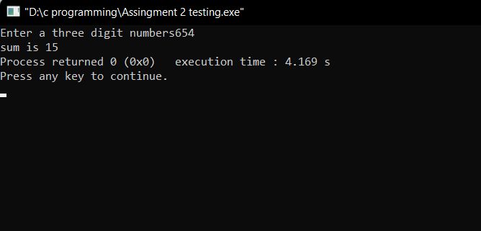

**6. Write a program which takes a character as an input and displays its ASCII code.**

#include<stdio.h>

int main()

{

char chr;

printf("Input any Character ");

scanf("%c",&chr);

printf("The ASCII value is %d",chr);

return 0;

}

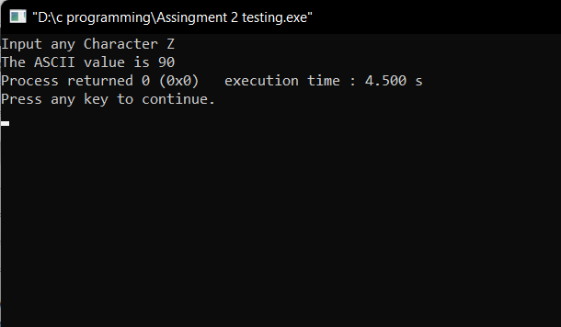

**7. Write a program to find the position of first 1 in LSB.**

#include<stdio.h>

int main()

{

int x=62,count=0;

int result=0;

while(x!=0)

{

result= x&1;

count++;

if(result==1)

{

printf("%d",count);

break;

}

x=x>>1;

}

return 0;

}

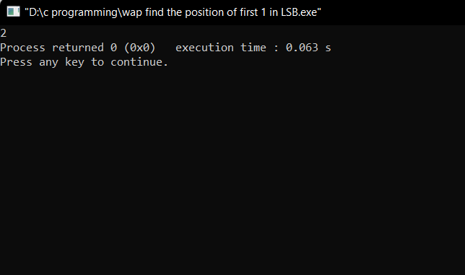

**8. Write a program to check whether the given number is even or odd using a bitwise operator.**

#include<stdio.h>

int main()

{

int x=5;

if(x&1)

{

printf("odd number");

}

else

printf("even number");

return 0;

}

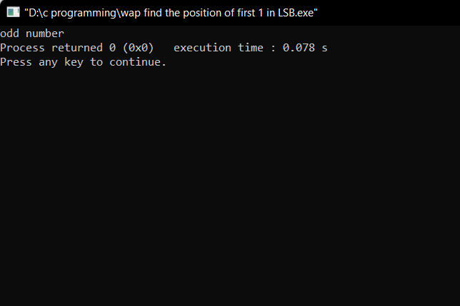

**9. Write a program to print size of an int, a float, a char and a double type variable**

#include<stdio.h>

int main()

{

printf("The size of the variables are");

int x;

char ch;

float z;

double d;

printf("\nint size is %d",sizeof(x));

printf("\nchar size is %d",sizeof(ch));

printf("\nfloat size is %d",sizeof(z));

printf("\ndouble size is %d",sizeof(d));

return 0;

}

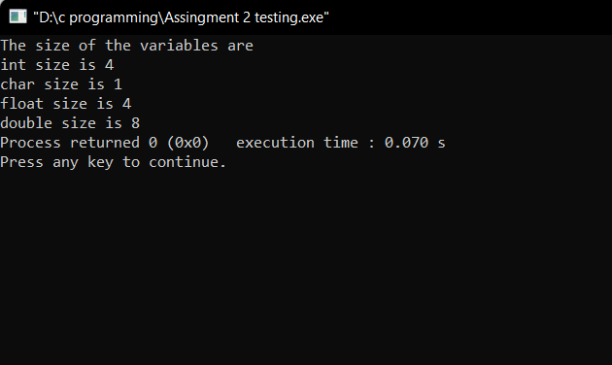

**10. Write a program to make the last digit of a number stored in a variable as zero.**

**(Example - if x=2345 then make it x=2340)**

#include<stdio.h>

int main()

{

int z,x=2345;

z=x/10;

printf("%d",z*10);

return 0;

}

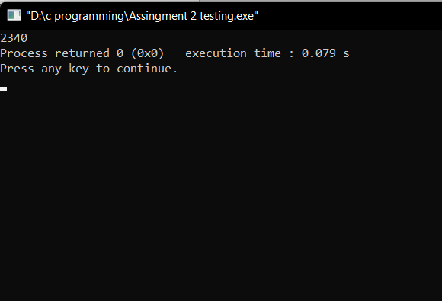

**11. Write a program to input a number from the user and also input a digit. Append a**

**digit in the number and print the resulting number. (Example - number=234 and**

**digit=9 then the resulting number is 2349)**

#include<stdio.h>

int main()

{

int num,extdigit,z;

printf("Enter a number");

scanf("%d",&num);

printf("Enter a digit to be appened in the given number");

scanf("%d",&extdigit);

z=num*10+extdigit;

printf("After Append the digit become %d",z);

return 0;

}

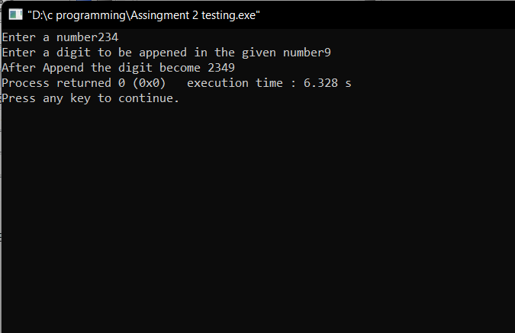

**12. Assume price of 1 USD is INR 76.23. Write a program to take the amount in INR and**

**convert it into USD.**

#include<stdio.h>

int main()

{

double i,u;

printf("Enter amount in INR ");

scanf("%lf",&i);

u=i/76.23;

printf("Amount in USD is %lf",u);

return 0;

}

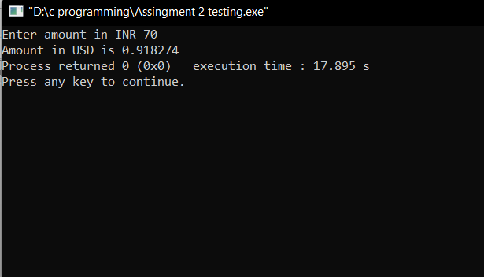

**13. Write a program to take a three-digit number from the user and rotate its digits by**

**one position towards the right.**

#include<stdio.h>

int main()

{

int num,x,z,y;

printf("Enter a number ");

scanf("%d",&num);

x=num%10;

z=(num/10)%10;

y=(num/10)/10;

printf("\nNumber After Rotation %d",(x*100)+(z*10)+y);

return 0;

}

